October 23, 2015

PRO-D DAY WORKSHOPS

October 23, 2015
ABCDE (Association of BC Drama Educators) presents "To The Moon and Back!"
ACPI-APPIPC (Association canadienne des professeurs d'immersion et l'Association provinciale de professeurs d'immersion et du programme francophone)
AEA PSA (Aboriginal Education Association Provincial Specialist Association) Annual fall conference “Indigenous Perspectives.”
AEGTCCBC (The Association of Educators of Gifted, Talented and Creative Children in British Columbia) “Designing High Quality Differentiated Units of Study: A Look at the Parallel Curriculum Model.”
Annual BCBEA PSA conference "BizTech 2015"
BC Dance Educators' Association Presents: Spirit of Movement 2015
BC School Counsellors' Association (BCSCA) Annual conference "Building Bridges"
BC Social Studies Teachers Association Living in a World of Conflict conference
BC Teachers of English to Speakers of Other Languages (formerly ESLPSA) 25th Annual Province-Wide Conference
BCATML’s (BC Associations of Teachers of Modern Languages) Annual PSA Conference Celebrating Languages!
BCCASA (British Columbia Culinary Arts Specialist Association) Annual fall conference "A Chef’s Adventure on the Sunshine Coast"
BCCLA & SEL–BC (formerly SRCLE) Present the 2015 Encompass Conference
BCMEA Conference
BCPTA Primary Leadership Conference Empowering Learning
BCScTA (BC Science Teachers’ Association) Catalyst 2015 Annual Conference “Thinking Like a Scientist”
BCTEA (British Columbia Technology Education Association) annual fall conference
BCTELA (BC Teachers of English Language Arts Conference: Story and the Landscapes of Learning
BCTLA (BC Teacher-Librarians’ Association) Annual fall conference “Charting New Paths”
Back to the Studio BC Art Association annual conference
Computer Using Educators of BC (CUEBC) Annual Conference
LATA (Learning Assistance Teachers’ Association) “Neuroscience Meets Education: Success for Struggling Students.”
PAGE BC Fall Conference
Provincial Intermediate and Middle Years Teachers’ Association Conference
Series for elementary early career teachers
THESA (Teachers of Home Economics Specialist Association) Annual fall conference “Home Economics: The Heart of Education.”

http://www.mineralsed.ca/s/TeacherWorkshops.asp

Home / Teachers / Pro-D Events / MineralsEd Workshop Schedule

MineralsEd Workshop Schedule
Every year, MineralsEd works with school districts and teachers' associations to present instructional workshops for teachers on their pro-d days. Workshops can be held anywhere in BC on a Pro-D day, during a PSA or other conference, or after school.
Registration is open to teachers, teacher-librarians, TOCs and student teachers, unless otherwise specified. Participants must be teaching the grade level or subject intended for the resource unit. There is a non-refundable $50.00 registration fee (per teacher), but no charge for resource kit materials, which represent a $250-$400 value. The host group may opt to cover the registration fee for their group members.
Pro-D organizers, read more about our MineralsEd Teacher Pro-D & Support.
If you would like to arrange a workshop for teachers in your area, contact MineralsEd at, info@mineralsed.ca(Email address obfuscated: enable JavaScript to view).

Upcoming 2015 MineralsEd in-service Workshops:

Grade 5 Integrated Resource Unit on Mining, Lower Mainland
Inman Elementary, 3963 Brandon St, Burnaby
Oct 23, 2015 Read More >>>
Grade 7 Resource Unit: Earth Sciences, Lower Mainland
Inman Elementary, 3963 Brandon St, Burnaby
Oct 23, 2015 Read More >>>
K-3 Integrated Resource Unit: Kids and Rocks, Lower Mainland
Inman Elementary, 3963 Brandon St, Burnaby
Oct 23, 2015 Read More >>>
Mining and the Environment
Ajax Project Site, Kamloops
Oct 23, 2015 Read More >>>

ARTS / FINE ARTS
A ‘Seasonal Celebration of Songs and Activities’ for Primary Teachers
Hands on Clay — Low Fire Handbuilding
Hands on Clay — Open Studio
Arts Integration - A Hands-on Introduction to Artful Learning
Technical Support and Creative Application for Digital Photography Across the Curriculum
SOCIAL RESPONSIBILITY & DIVERSITY
FRIENDS Child
Get Eddie: An Interactive Approach to Protecting Students from Online Harassment and Sexual Exploitation
SPECIAL EDUCATION
Sensory Processing and Self Regulation
CPR Training

Oct 23 External Pro D Workshops
Minerals Ed: Earth Science, mineral resources & mining in the classroom
MineralsEd Natural Resources Harbour Cruise
3 Principles Pro D for K-12 Educators on Salt Spring Island
Making Spaces Transforming a Classroom Through the Creative Process
Edu Talks Educational Seminars for the 21st Century
Neuroplasticity and Education: Strengthening the Connection
Harriison River Pro D Adventure
Printing Without a Press
World Music for Classroom Teachers (k-12)
Historical Chinatown Tours
World Music for Classroom Teachers (K-12)

PRO D DAY Conference – October 23, 2015 Topic ” A Glimpse into the Reading Brain and The Challenge of Dyslexia http://www.ldafs.org/event/pro-d-day-conference-october-23-2015/

Back to Calendar
Tickets
Add to Calendar

Click to view map

When:
October 23, 2015 @ 9:00 am – 12:30 pm

Where:
Bear Creek Community Church
8383 140 Street
Surrey, BC V3W 5K9
Canada
Cost:
$20.00 + processing fee
Contact:
Vicki Nelson/Carol Bennington
604-591-5156
Email

Professional Development OPPORTUNITIES
https://www.bctf.ca/PDCalendar/index.cfm?action=month&month=10&year=2015
Links to Conference Sites
- Association for Supervision and Curriculum Development (ASCD) Conferences
- Autism Community Training
- Continuing Studies in Education at the University of Victoria
- Crisis and Trauma Resource Institute Inc.
- Gordon Neufeld, making sense of kids
- Institute for Boosting Social Responsibility/Watters & Associates
- Investigating Our Practices (IOP) Annual Conference, UBC Faculty of Education
- Jack Hirose and Associates Inc. workshops for education and mental health professionals'
- Justice Institute of British Columbia
- Mentoring Boys
- Naramata Centre
- Phi Delta Kappan (PDK) International
- Solution-Focused Counselling workshops by Nancy McConkey
- The Saltspring Centre of Yoga
- University of British Columbia Faculty of Education, Professional Development & Community Engagement
- UVic Centre for Early Childhood Research and Policy

Oct. 24
Canadian Art Therapy Association 35th Annual Conference
http://www.kutenaiarttherapy.com/web/events/item?item%5fid=123996
Nelson, BC

ONGOING
Pre-recorded Webinars on a variety of topics from the Crisis and Trauma Resource Institute (CTRI)
http://www.ctrinstitute.com/webinars
Online

Where The Wild Things Are October Pro-D

http://camosunblog.blogspot.ca/p/where-wild-things-are-october-pro-d.html
That very night in Max's room a forest grew, and grew, until the ceiling hung with vines, and the walls became the world around...",
- Maurice Sendak, Where the Wild Things Are.
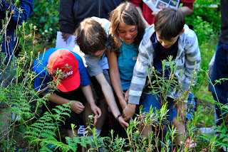
Bog Buddy program. photo credit: Marian De Geer,
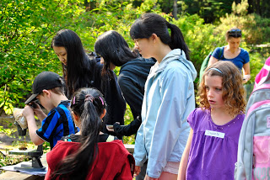
Biology 11 students teach elementary students in Camosun bog: photo credit: Marian De Geer
When: October 23, 2015 9:30 - 12:30 pm
Where to meet: Entrance of Camosun Bog (map)
Who can register: youth leaders, urbanists, teachers, informal educators, student teachers. Register by contacting Susan at codesignyouthmanual@gmail.com. (If you are a teacher, please let us know if you are secondary or elementary).
Cost: free:
Presenters: VSB teachers, The Camosun Bog Restoration Group, Metro Vancouver Regional Parks interpreters, and Co-Design Group
Dress code, what to bring:
This is an outdoor program happening rain or shine. Be prepared for rain. Bring your favourite tea mug.

Join the Crazy Boggers, Metro Vancouver Regional Park interpreters and VSB teachers for an active and informative Pro-D walking through an enchanting urban bog! Learn the fascinating story of this ancient ecosystem and methods for interpreting the bog for students of all ages. Taste Labrador Tea, touch a carnivorous sundew and Jump on a bog trampoline! Walk away with lesson strategies, classroom resources and the ability to identify at least five bog species and five invasive species, guaranteed!
Purpose of this workshop:
To give educators the tools to bring their classrooms and small groups to the bog with confidence
To familiarize educators with the bog narrative, bog ecology and share connections to the elementary and secondary curriculum.
To encourage educators to visit our bog. Camosun bog is the most transit - accessible bog in Vancouver and we encourage everyone to experience this treasure in the city
Our presenters have experience interpreting the bog for elementary students and secondary students up to senior secondary. Furthermore, the metro vancouver regional parks interpreters are well versed in presenting the bog in an informal context. The bog is a great outdoor classroom for the following topics:
plant anatomy
ecological succession
bog ecology
bryophytes
plant competition
urban geography
local history of our city
and it is a wonderful location for inspiring students to create art, poetry, short stories.
All participants will be entered into a draw to win a copy of a book for their school library or organization. Sue Ann Alderson's book was written about Camosun Bog. Courtesy of Trade Wind Books

http://www.richmondartgallery.org/teacherspage.php
ART FOR TEACHERS:
Professional Development Day Workshop
Friday, October 23, 2015, 9:30am – 3:00pm
Get back to nature with innovative classroom art projects! This workshop features art lessons that incorporate science and the natural environment through a variety of art mediums, inspired by our current exhibitions For All is For Yourself and not by chance alone. These artworks illustrate the ways that art can be inspired by both the science and beauty of nature, and that art can engage the public in creative solutions to environmental issues. Includes art materials, lesson plans and light refreshments (lunch not included). $40 per person, pre-registration required.
Register early as space is limited!
To register quote course # 1139158
Online: www.richmond.ca/guide
By phone: 604-276-4300
In person: Richmond Cultural Centre, 7700 Minoru Gate
For more information about the School Art Program contact Melanie Devoy at mdevoy@richmond.ca or 604.247.8316

Sports Institute

http://www.douglascollege.ca/programs-courses/continuing-education/sports-institute
T​he Douglas College Sports Institute, in conjunction with
Physical Education British Columbia (PE-BC) are proud to present:

29th Annual Elementary & Secondary School Teachers’ Conference

(NOT just for Phys-Ed Teachers and Coaches!!)

2015 QDPE Pro-D Conference

Friday, October 23, 2015
​with Keynote Speaker: Former NBA Point Guard, Dan Dickau
​Douglas College’s 29th annual Physical Education Professional Development Conference offers you and your colleagues over 40 workshops of dynamic learning activities that can be applied at both the elementary and secondary level.

CLICK HERE FOR 2015 QDPE CONFERENCE BROCHURE

Professional Development Opportunities (October 23 – Pro-D Day)
Show entries
Search:
Date | Assocation | Event | Location | Description | Contact
October 23 – 24 | ABCDE (Association of BC Drama Educators) | "To The Moon and Back!" | TBD | This beloved annual fall conference will inspire and refresh with workshops in a variety of dramatic arts, including acting and musical theatre, stagecraft and tech theatre, and using drama as a tool for social justice conversations in the drama and non-drama classroom. Reach for the stars in workshops for elementary, middle, secondary and TTOC's. Conference package includes an incredible dinner and fabulous entertainment where delegates can mix, mingle, share and network with each other. | Contact: Gordon Hamilton at ghamilton@sd35.bc.ca or Lana O'Brien at lobrien@sd22.bc.ca
October 23 | AEA PSA (Aboriginal Education Association Provincial Specialist Association) | Annual fall conference "Indigenous Perspectives" | Langley | Keynote and workshops relating to new BC curriculum, including new Residential School curriculum, incorporating Aboriginal content into curriculum, Deconstructing Myths, Shannen’s Dream, cultural activities, and more. | Contact: Bertha Lansdowne at blansdow@sd40.bc.ca
October 23 | AEGTCCBC (The Association of Educators of Gifted, Talented and Creative Children in British Columbia) | “Designing High Quality Differentiated Units of Study: A Look at the Parallel Curriculum Model” | Vancouver | Keynote Speaker: Marcia Imbeau.  Participants will be introduced to the Parallel Curriculum Model and will be shown how to create meaningful, emotive, and engaging curriculum. | For more information and to register, visit aegtccbc.ca, or call Elizabeth Ensing at 604 574 0465.
October 23 | ArtStarts | "Making Spaces: Transforming a Classroom Through the Creative Process" | Vancouver | Is a classroom ever just a classroom? ArtStarts invites teachers to take part in an experiential professional development event on October 23, 2015 that will explore how to you can transform your students’ learning experience through the creative process. Making Spaces is a full day at the ArtStarts Gallery that will engage your creativity with two hands-on workshops, while exploring arts integration as an approach to teaching. All participants will take part in two workshops, "Documenting the Hard-to-Document: Zine Making with Tin Can Studio" and "Gallery as Classroom, Classroom as Gallery with Elfred Matining".  ArtStarts in Schools is a not-for-profit organization that provides innovative arts programs for young people, practical resources for teachers and artists, and leadership in advocacy for arts in education.  Making Spaces takes place on Friday, October 23, 2015, 9:00 a.m. to 3:00 p.m. at the ArtStarts Gallery and Resource Centre, located at 808 Richards Street in Vancouver, BC. | Learn more and register online at artstarts.com/infusion
October 22-24 | BC Association of Mathematics Teachers (BCAMT) | 54th Northwest Mathematics Conference "Scaling New Heights" | Whistler | Opening Keynote: Thursday October 22 at 7:30  KEYNOTES:  • Ron Lancaster  • Egan Chernoff – @MatthewMaddux  • Simon Singh @SLSingh  EARLY BIRD REG:  $90 (Pre-service teachers)  Stay at Fairmont Chateau or Westin Whistler. Hotel rates start at $139 (+taxes, etc.) | Conference registration and program details found: www.bcamt.ca/nw2015
October 23 | BC Dance Educators' Association | "Spirit of Movement 2015" | Shadbolt Centre for the Arts, Burnaby | An invitation to all elementary and secondary teachers of dance, drama, music, physical education and classroom teachers. Classes in Aboriginal Dance, Hip Hop, Contemporary Ballet, Creative Dance and more! | Contact: psac73@bctf.bc.ca  Website: www.bcdea.ca
October 22-23 | BC School Counsellors' Association (BCSCA) | Annual conference "Building Bridges" | Pacific Gateway Hotel, 3500 Cessna Drive, Richmond | Building Bridges and Creating Connections is an integral part of supporting youth and the keynote speakers and workshop presenters, Stan Kutcher and Tammy Fisher will be providing insight and strategies for doing building support networks around youth. | Contact: Marci Statham at marci.statham@gmail.com  Registration: www.bcscaconference.ca.
October 23 | BC Social Studies Teachers Association | "Living in a World of Conflict" conference | Vancouver Technical Secondary School | Keynote speaker: Dr. Samantha Nutt. Each year, the BCSSTA hosts a professional development conference open to all teachers who teach social studies in BC schools. We offer a compelling keynote address which leads you into further workshops spread over two session-periods. The majority of workshops offered will tie into this year’s conference theme of “Living in a Word of Conflict”.  We expect a wide variety of specific workshops to be available. Between the morning and afternoon workshop sections there will be a hot buffet style lunch served (part of your fee) and there will be a host of vendors and organizations with tables in the cafeteria and around the school offering information, free samples, and draw prizes. We also hold the Annual General Meeting of the association in the staff cafeteria next to the main cafeteria. We strongly encourage you to drop in and take part in the AGM. | Contact: bcssta@gmail.com  Website: bcssta.wordpress.com/10-2  Registration: www.bcsstaconference.ca
October 23 | BC Teachers of English to Speakers of Other Languages (formerly ESLPSA) | 25th Annual Province-Wide Conference | Vancouver | Come speak with, as well as listen to, our keynote To rspeaker, international student mentor  Sam Thiara from SFU and GradusOne. Our many workshop presenters, members of BC TESOL's executive, our SELECT STUDENT PANEL, and hundreds of colleagues from across BC! Let's gather to connect on the themes of ACCESS, APPLICATION & ADVOCACY: How can students and teachers learn to request help from and offer help to each other? | Registration: BCTESOL.ca.

Exploring Nature's Classroom Workshops for Teachers on Surrey's Pro-D days

http://www.bcfieldtrips.ca/exploring-natures-classroom-workshops-teachers-surreys-pro-d-days
Offered by Surrey Nature Centre and last updated on July 28, 2015.

Description
Inspire, engage and connect your students with nature. Gain confidence teaching in the outdoors as you learn hands-on games and activities. Explore the natural beauty of Green Timbers Park while identifying plants and animals. This is an introductory level workshop for elementary teachers. Workshops are held on Surrey's Pro-D days. Please contact Surrey Nature Centre at 604-502-6065 to register.
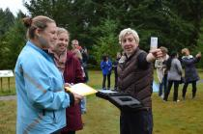 | 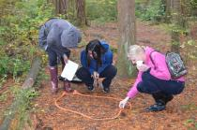 | 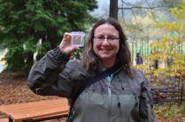

Trip Details & Availability
Curriculum | English Language Arts, Environment, Fine Arts, Sciences
For Grades | K, 1, 2, 3, 4, 5, 6, 7
Months Available | February, May, October, November
Days Offered | Monday, Friday
Times Offered | 9:00 am
Duration | See notes.
Max. Students | 30
City | Surrey
Trip Packages | Post-Visit Information Package
Additional Audiences
Offered In French? | No
Additional Notes | Workshops will be held on October 23, 2015 | November 13, 2015 | February 19, 2016 | May 6, 2016 | May 30, 2016

Fee Details
Cost Per Student
Cost Per Adult | $30
Fee Notes

Pro-D Canoe Adventures
Join us in the great outdoors for a canoe paddle through the waters of one of TWO amazing locations: Harrison River OR Barnet Marine Park. During these trip will you see beautiful wildlife, and the sights that the waters and land around British Columbia has to offer. You will experience these sights together in our 25-Foot Voyageur Canoes. We tailor this program to a number of Prescribed Learning Outcomes, please contact us for more information.

Harrison River Salmon Run Pro-D Canoe Adventure
- Date: October 23 2015
- Time: 8:30am-3:30pm
- Cost: $52.45 (includes taxes, lunch and snacks)
- How To Register: send an email to info@ridgewilderness.com with your name, email, and phone number, and specify that you would like to take part in the Harrison River Pro-D Canoe Adventure.
- Registration Deadline: October 13 2015

Comox Salmon Run Pro-D Canoe Adventure
- Date: TBA
- Time: 8:30am-3:30pm
- Cost: $52.45 (includes taxes, lunch and snacks)
- How To Register: send an email to info@ridgewilderness.com with your name, email, and phone number, and specify that you would like to take part in the Comox Pro-D Canoe Adventure.
- Registration Deadline: TBA

PLAY IS THE WAY

ONE DAY OPEN PRO-D WORKSHOPS
Attending a Pro D workshop is the perfect opportunity to discover all the benefits of
PLAY IS THE WAY® for your school community. Suitable for teachers, teacher support staff, principals, vice principals and counsellors, workshops are participatory, practical and give you a hands on experience of
PLAY IS THE WAY® in action.
for schools wanting to host a whole school Pro-D CLICK HERE.
WORKSHOP DATES BELOW:
(Scroll down to find a location near you - Venues to be advised)
- Workshops are open to educators from any school or district.  - Open workshops are held at regular intervals throughout the year at various locations.  - COST: $175 per participant (Plus GST)  - Each attendee receives a copy of Children Aren't Made Of China by program founder, Wilson McCaskill and a certificate of participation. | 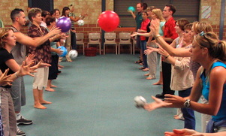
Presenter: Sean Smith  "I really enjoyed your energy, enthusiasm and expertise with this important and timely material. The pillars of the program seem really sound and you are passionate about presenting them. Thanks Sean."  Robert King - Counsellor - School District # 83. | Time: 9am - 3pm  "Excellent workshop! The power is in the application of the beliefs of the program and in the activities that are engaging and fun. Teaching and learning in the moment."  Wendy Forsythe – Principal

BENEFITS:  - Opportunity to assess the workshop and program before considering both for your school.  - Gives small schools the opportunity for staff Pro D.  - Pro D for new teachers to a school already using the program.  - Networking opportunities with other participants.  - Establishes an understanding of the power of games for developing positive social behaviour.  - Empowers participants with a meaningful language and effective strategies to help children be independent and self-managing.  - Uplifting, energizing day of thought provoking activity and information that can be used immediately.  - Each attendee will receive workshop notes and a certificate of participation. | FEATURES:  - Training in the use of the PLAY IS THE WAY® program using physically interactive games for the development of positive social behaviour.  - Full day – 3 x 1.5 hour sessions.  - Hands-on participation in games and activities.  - Demonstrations of strategies and the supporting language.  - Limited numbers means maximum involvement.  - No whiteboards or power point presentations.  - Resources available for purchase at discounted prices.  - Arrival tea & coffee, morning snacks and lunch are provided.

CLICK ON THE WORKSHOP OF YOUR CHOICE TO REGISTER
http://www.playistheway.ca/open-pro-d-workshops.html
BRITISH COLUMBIA
- COQUITLAM - Friday 23rd October 2015

It’s HERE!! http://bctela.ca/
Written August 28, 2015
The BC Teachers of English Language Arts presents its Fall Conference:

Story and the Landscapes of Learning
October 23rd, 2015
Matthew McNair Secondary School
9500 No 4 Road
Richmond, BC
Story and the Landscapes of Learning brings together educators who are committed to teaching practices that respect and engage diverse learners. This year we feature sessions focusing on inquiry, diverse texts, indigenous perspectives, the new curriculum and stories of place and learning.
Featuring: Richard Wagamese, David J. Smith, Faye Brownlie, Sharon Jeroski, Leyton Schnellert, Carl Leggo, Dale Allender and many more!

Brochure:
Conference Brochure 2015

Register
BCTELA Fall Conference Registration

Posted in Blog, Conference | Tagged conference

BCTELA Book Club Chat 1
Written July 9, 2015
We held the first of our chats around place-based education and pedagogy today

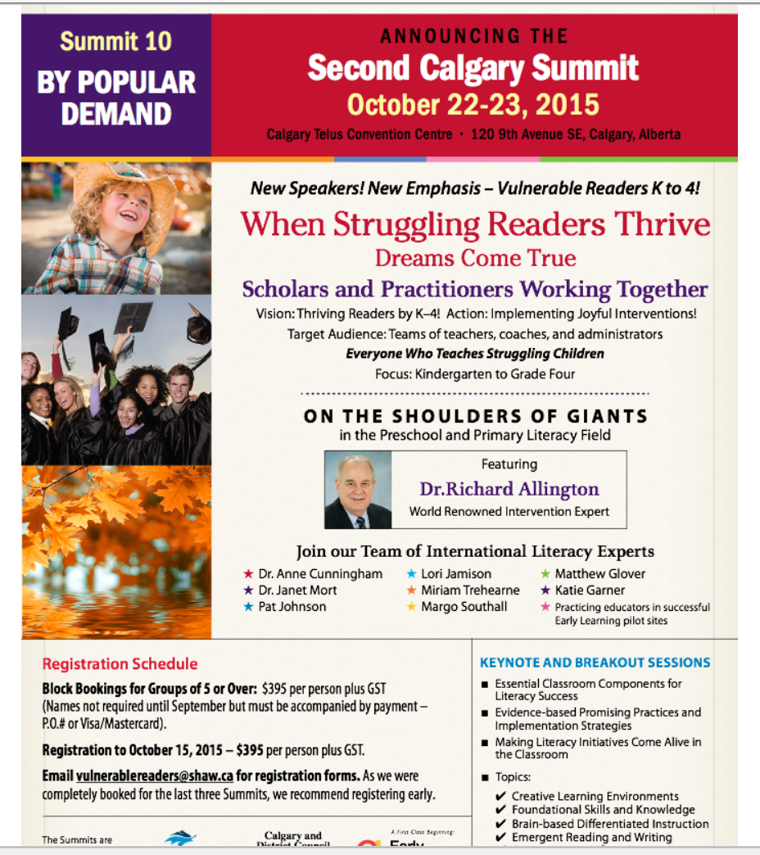
- http://www.vulnerablereaders.ca/The_Summits.html

http://www.sd5.bc.ca/staff/literacy/proD/Documents/ChangingResultsFlyer.pdf

CUEBC.ca
Computer Using Educators of British Columbia
http://cuebc.ca/conference/sessions.php

Sessions
CUE Executive September 15, 2014 Sessions2015-07-15T23:50:39+00:00

CUEBC Conference October 23th, 2015

Byrne Creek Secondary School

7777 18th Street
Burnaby, BC V3N 5E5
Click here for a complete list of sessions and times or go to cuebc.ca/conference/sessions.php
Click here for the Mobile Site or go to myapp.is/CUEBCEVENT
Some sessions may be cancelled or moved, check back often to confirm the time and location of the sessions.
There is no pre-registration for the individual workshops/sessions. Choose the workshops/sessions you would like to attend on the day of the conference.
CUEBC Sessions For October 23, 2015
Byrne Creek Secondary

Mobile Conference Site CUEBC Conference Home Contact Us
Sessions Confirmed
Flipping your Classroom - Start Small, Learn Big
Session:
Instructor: Jerry Bleecker
Room:
Audience: Secondary Level
"Flipping your Classroom - Start Small, Learn Big" examines the flipped classroom model. As the title indicates, I discuss my professional journey from flipping first lessons, to screencasting, hosting material online, advantages of a flipped approach, and how to encompass a project/inquiry-based learning mindset. The session also examines bring-your-own-device (BYOD) strategies.
A proud MET graduate, this is my sixteenth year teaching Biology, Information Technology, Science, and Mathematics at College Heights Secondary, in School District 57. In 2013, I flipped two classes, offering eCampus Biology 11 & 12. Combining project and inquiry learning in a blended environment is my professional odyssey. I am an advocate of educational technology, BYOD strategies, and the use formative assessment as means to empower the critical thinkers and makers of tomorrow. Providing professional development and sharing with communities of practice is essential in gaining wisdom from reflection while learning from the experiences of colleagues and interactions with students.
Project Based Learning with the use of Technology
Session:
Instructor: Davinderjit Sandhu
Room:
Audience: Primary Level
This presentation offers ideas for project based learning in the classroom with the integration of technology. Learn a fun and hands on approach to learning and developing further concepts taught with using the iPad and a variety of Apps and using the computer for certain programs.
I was born and brought up in England and completed my teaching degree there. I have been teaching in the Lower Mainland for just over twelve years and specialize in ELL (ESL). I have three children of my own and am very passionate of my profession. I have spent a few years of my teaching as a TOC and was called to cover many ESL classes. This provided me with insight to the different ways that ESL was being taught. I am currently teaching ELL full time and wanted to implement the program in a fun and motivating way for the students. It is working!
RSA Animate Style PLUS Common Craft Style video. Non-artists welcomed.
Session:
Instructor: Lisa Donovan
Room:
Audience: General
Critical thinking, risk taking, and collaboration can deepen learning. Integrating the arts into your curriculum is one approach. But does art intimidate you? No problem! Even you can create a blend of RSA Animate Style PLUS Common Craft Style video. Then take that strategy into your classroom to deeply engage your students. This presentation will demonstrate: re-purposing an overhead projector; preparing for drawing; filming and lighting; moving clips from the iPad to the laptop using iCloud; editing in iMovie; and adding voice over. Lisa's personal successes and challenges will be shared as well as teacher examples.
Lisa is currently seconded to SFU as a Faculty Associate for Field Programs, instructing inservice teachers in a 2-year Graduate Diploma Program. She is currently facilitating these programs: Teaching with Technology in a Global Classroom (Delta cohort), Frameworks for Innovative Teacher Collaboration and Inquiry (North Van), and Collaborative Frameworks for Innovative Learning Design (Surrey). She includes hands-on RSA Animate Style PLUS Common Craft Style video instruction in her New Literacies and Emerging Technologies course. For her Masters of Educational Practice, Lisa presented her final comprehensive exam using RSA Animate style video. Lisa is a former SD38 ICT secondary teacher.
Introduction to the Arduino Board
Session:
Instructor: Bernhard Zender
Room:
Audience: General
After a five minute introduction with slides and movie clips, participants will be provided with a set of items consisting of an Arduino Board as well as a number of sensors and actuators. They will then use an online setup of materials plus help from the instructor to get started on using this microcontroller board to do simple tasks and understand the basics of its programming. Participants should bring a laptop computer, at least one laptop per team of two.
Staff instructor at UBC Engineering Physics, working with undergrad Applied Sciences and Engineering Physics students from first to fifth year, as well as undergrad and grad students from other faculties such as the Sauder School of Business.
Show Your Story with Adobe Voice
Session:
Instructor: Gary Toews
Room:
Audience: General
Adobe Voice is a Free iPad app that helps anyone create stunning animated videos in minutes. In this Hands-On workshop you will: Create a narrated multi-media project, explore sample classroom projects, and discover how you can integrate Adobe Voice into your teaching practice iPads will be provided for those who do not have access to one. Those bring their own iPad should download Adobe Voice prior to the workshop.
Gary has been Technology Helping Teacher for the past 16 years in Abbotsford School District. Current projects include iPad integration, GAFE projects, and increasing teacher's effectiveness through online tools. Other interests include web development, singing, playing bass guitar and country living on the farm with his family of 4 kids and his wife Karolyn.
3D Printing - One Teacher's Experience
Session:
Instructor: Lisa Mulzet
Room:
Audience: General
This is an introductory session for those considering 3D printing technology for their own classroom or personal use. Lisa Mulzet will outline her own journey with 3D Printing in her high school technology classroom and provide tips for those interested in using a 3D printer in their school or at home.
Lisa Mulzet has been a teacher since 1993 and has taught in elementary, middle and secondary schools. She is currently teaching grades 9-12 in Technology Education and ICT at Centennial School in Coquitlam.
Flipping 101: The What, Why, and How of the Flipped Classroom
Session:
Instructor: Sean Robinson
Room:
Audience: General
Thinking of flipping? Not sure where to start? Come to Flipping 101 and find out about this great way of using video to engage students in and out of the classroom. This session will cover what the flipped class looks like, why try it, and how to get started. You'll leave this session with an understanding of what students think of the flipped learning, apps that work alongside the flipped class, and some tips for inspiring student engagement.
Sean Robinson has been teaching for over 20 years in classes from kindergarten to high school in cities from Jarkarta to Vancouver. Considered one of the top project-based learning teachers to follow on twitter by The Guardian, he enjoys sharing his classroom trials and triumphs with other educators to move education forward. He has a passion for guiding teachers to employ more effective pedagogy and along with flipped learning, he leads workshops on project-based learning, assessment, digital citizenship, and technology in the classroom. He blogs about his educational journey at seanrtech.blogspot.ca
Open-ended play and problem-based learning with Scratch
Session:
Instructor: Wendy Hoy
Room:
Audience: Intermediate Level
Discover if Scratch can facilitate learning in your classroom. Scratch is an online community where you can program your own interactive stories, games, and animations. In this workshop, you�ll work in small groups to share prior knowledge, develop possible hypotheses, and identify issues to be researched. You�ll then have the opportunity to research, explore, and experiment with Scratch on your own. At the end of the workshop, you�ll share your findings and determine next steps. By collaborating with other teachers and having your own open-ended play, you�ll determine if Scratch is right for you!
Wendy is dedicated to creating engaging learning experiences for children through technology. She believes that computer programming isn�t just a skill for computer scientists and engineers; it�s also a tool for learning. After graduating from UBC with a degree in computer engineering, Wendy worked for companies such as Microsoft, Sony, and Electronics Arts. But while at work, she felt a growing need to give back. By 2014, she started teaching Coding for Kids at local community centres, and by 2015, she began offering Coding for Kids to elementary schools through her non-profit organization, Marshmallow Coding Education Society.
How students use microcontrollers, robotics and 3D printers - An Inquiry Hub demonstration
Session:
Instructor: John Sarte
Room:
Audience: General
This workshop will begin with a short panel discussion with Inquiry Hub students as they discuss the use of computers and other technologies at school. Then, the students will lead a variety of mini-sessions with participants to demonstrate the potential use of various technologies in the classroom, for example, 3d printers and foam cutters. Time will be allotted for participants to get some hands-on experience with processes of design and coding. The session will end with a discussion on application, implementation, value, costs, and questions from the participants.
I am currently a STEAM facilitator at Inquiry Hub Secondary in the Coquitlam School District. For the last 3 years, our school has been developing a blended learning model where students collaborate on inquiry projects. I have over 10 years of teaching experience in math and science. I also have a strong interest in the maker classroom.
Coding For Newbies: An Introduction To The 21st Century's Most Valuable Skill
Session:
Instructor: Khurram Virani
Room:
Audience: Secondary Level
The workshop will provide a quick overview of why coding is so valuable, dive into some basics of how coding works and provide some guidance and resources as to where and how they should approach code. Attendees will leave with concrete skills that make them more valuable to employers, and get them a taste of code that demystifies tech's greatest frontier.
Khurram has a strong passion for two things: coding and teaching. This is what drove him to co-found and teach at Lighthouse Labs. He is also a Partner and former CTO at Functional Imperative, a boutique software agency which has hired several of his own Lighthouse Labs graduate. In other words, he codes his own lunch, and eats his own dog food.
Getting Started With Arduino
Session:
Instructor: Benjamin King
Room:
Audience: Secondary Level
Arduino is an opensource electronics platform that is simple to use and easy to learn. This hands-on session will introduce participants to the Arduino and provide some simple projects to use in their classrooms.
Ben King is a electronics teacher at John Oliver Secondary School.
Diarama meets Hollywood! Stop-Motion Photograhy
Session:
Instructor: Bryon Carpenter
Room:
Audience: General
Remember Wallace and Gromit or the recent film The Boxtrolls, created with claymation and stop-motion photography? Have you ever make a flipbook in elementary school? Today, apps and software allow us to create stop-motion movies much easier, while the process remains the same. This workshop will discuss some background and how to use specific apps on mobile devices to create and publish stop-motion movies. Students and teacher alike will be able to tell their story on a different kind of stage. Suggested app: install the free version of "Stop Motion Studio by Cateater" on your tablet; a small number of iPads will be available for this workshop.
Bryon began "teaching" through the Science and Innovators in Schools program (Science World) while a chemist in Langley. A career change took him to SFU for PDP, then SD34 as a classroom teacher, as an online teacher at AVS, and now to the role of EdTech Helping Teacher in SD34. As a husband and father of 3, he find his passion interacting with students and teachers eager to learn math, science and technology. Bryon taught at the Abbotsford Virtual School from 2010-2015 and enjoys engaging students through technologies, Recently he has moved to the role of an EdTech Helping Teacher for SD34. Remember, technologies are mere tools being wielded to enhance our human endeavour called education. B.Ed (2009), M.Sc. (2000), B.Sc (1997)
iMovie in the News
Session:
Instructor: Paul Klintworth
Room:
Audience: General
Come and learn how teachers collaborated to run a cross-curricular bilingual video news reporting team. Grade 5 students connect with school activities across all grades and subjects reporting in English and French. Students generate the story ideas, as well as plan interviews and film events. This session will show examples from broadcast episodes, as well as the editing process behind the scenes. The focus is on iMovie, but can be adapted for any video editing software using greenscreen and other effects. Resources: http://thecw5.weebly.com/episodes
Paul has taught Primary classes in the UK and in BC, and was also an Advisory Teacher for IT in Bristol, UK for one year. He can thoroughly recommend the MEdTech at UBC! Currently he is the Technology Integration teacher for the Wentworth Campus at Collingwood School, responsible for JK - Grade 5.
Technology in the Humanities Classroom
Session:
Instructor: Linda Kwan
Room:
Audience: Secondary Level
Overview of topics: BYOD, Wikispaces for teachers, Blogs and e-portfolios for students, OneNote for teaching, Socrative for assessment. Participants should bring a laptop or tablet (iPad if you have one) or minimally a smartphone, to be able to participate in the hands-on portion of the workshop.
I'm an English teacher, food blogger, and prior VSB Learning Technologies Mentor. I've been teaching 25 years (the last 18 at University Hill Secondary). In July 2012, I completed my graduate diploma in Leadership at VIU. My instructors Linda Kaser and Judy Halbert, authors of "Spirals of Inquiry" kick-started my personal Inquiry to mentor educators. As an Inquiry Facilitator, I show educators how to build their PLN, employ current research concerning technological trends in education and give hands-on workshops that provide teachers with skills to immediately employ in their classrooms.
Fun with Photoshop (and Lightroom)
Session:
Instructor: Dan WiebeDaniel Wiebe
Room:
Audience: General
This workshop will be in two parts. The first part we will look how to edit your photographs using photoshop and take a brief look at its cousin Lightroom. We will take a look at adjusting lighting, colour and contrast and more. The second part will be creating simple pictures using the drawing tools in photoshop. Ample time for playing will be provided.
Dan has been a computer using education since Windows 95 was popular and supported. Currently he is teaching his grade 6 and 7 students using technology at Minnekhada Middle School, but in the past he has been a computer teacher in both the middle and high school level.
Grading with Google
Session:
Instructor: Drew Murphy
Room:
Audience: Intermediate Level
Teachers everywhere are embracing Google tools for the way they offer effective assignment delivery and enhance student productivity. However, grading all this student work in Google is still fraught with inefficiency and awkward workflows. In this workshop we'll look at ways to improve your overall online grading experience. We'll also explore how a free application, called Gradelicious, enhances your Google grading efforts right away by saving you tons of time and creating a more professional workflow.
My name is Drew Murphy. I am a technology/planning teacher at Chatelech Secondary in Sechelt, British Columbia. I teach and manage an in-school online Planning and Portfolio program. I have been involved in pioneering online programs and methods in my district for the past 25 years. During this time, I've also been an educational consultant in designing online learning systems. I have a passion for teaching in the online environment and I believe it is a medium that can enhance the art of teaching and the act of learning.
Robotics in the Classroom
Session:
Instructor: Brian Yu
Room:
Audience: General
This workshop session will cover a range of topics from how to start a program in your school to what skills and capabilities your STEM students would have as they exit your program. Additional discussions will also include the concept of 'transformational teaching' as a management strategy, as well as how to take your robotics program out of the classroom and into the competitive world of robotics competitions. There will be a short hands-on demonstration towards the end of the session.
Brian Yu is a technology teacher with the Vancouver school district. As an event organizer for the VEX robotics program, Brian has been promoting the use of robotics as an educational tool to provide opportunities for students to engage in hands on learning in the field of Science, Technology, Engineering, and Mathematics (STEM).
Student led inquiries and other messy projects
Session:
Instructor: Rory Payment
Room:
Audience: General
What technologies work well for designing student led inquiries and other messy projects? How do you get students taking more ownership for their learning? How can technology be used to measure the learning in a genius hour? How does technology tie into the proposed new competencies? We will talk about successful strategies for designing, implementing and assessing student led inquiries.
Rory Payment has been the K to 12 district helping teacher for Inquiry Learning and Technology for 9 years. He spends most of his time working with teachers to create, implement and assess inquiry and real world projects that best meet the needs of each individual. One his main projects is supporting 1600 grade 6/7 students who receive an iPad or Windows tablet to use for the year.
My Battery is Low...and I forget my password
Session:
Instructor: Rory Payment
Room:
Audience: General
How does technology enable students to be less productive and what can we do about it? How do you allow students to have choice and autonomy on a computer, develop self-regulation skills and build a productive classroom community? In this workshop, we will look at strategies for working with a wide range of students' abilities and inabilities to help ensure their productivity.
Rory Payment has been the K to 12 district helping teacher for Inquiry Learning and Technology for 9 years. He spends most of his time working with teachers to create, implement and assess inquiry and real world projects that best meet the needs of each individual. One his main projects is supporting 1600 grade 6/7 students who receive an iPad or Windows tablet to use for the year.
Websites for the Classroom: How to build and use a Weebly website
Session:
Instructor: Sean Smith
Room:
Audience: General
This is an introduction to building a website for your classroom using Weebly. You will walk away with a site, a basic understanding of how to manage that site, and tips and ideas for how you can use a Weebly website for your classroom. You will also learn to use Weebly with your class so your students can build sites for their own work. (A basic understanding of how to use a computer ie: what a browser is and where the address bar is, will help). You will need a laptop to participate in this workshop.
Sean Smith has taught since 1996 in the Vancouver School District. He Has been using technology, both web-based and computer-based, for the past decade with students of all abilities. He has used technology tools for small resource groups and full classrooms alike. Sean has hosted many workshops for educators, administrators and support staff to support their use of technology.
Making Presentation Using Adobe Voice and Adobe Slate
Session:
Instructor: Chris WaltonRon Dorland
Room:
Audience: General
Participants will learn and create amazing audio and visual presentations using Adobe Voice and Adobe Slate. Step by step instruction and hands on creation will make you an 'expert' by the end of our session. These Apps support a Universal Design approach as they are applicable and accessible to students of all grade levels and abilities. All participants will need to bring an iPad and have the ability to download these two free Apps. These free and easy to use platforms will improve digital literacy in your classroom and excite your students as they have new, "cool", ways to express their voice. All students can potentially improve their literacy skills by using these tools.
Chris Walton is currently a Learning Support Teacher in the Surrey School District. He is a former Assistive Technology Coordinator who continues to works with teachers in a variety of contexts: as a workshop presenter, instructor and mentor. His passion is to support classroom and special education teachers as they discover how to use technology to empower their students. You can follow him on twitter: @ipadtestkitchen.
Ron Dorland has been teaching for seven years and currently is in a grade 7 classroom position. He is the co-founder and moderator of #7thchat. Ron is a motivator who has presented at numerous district and provincial workshops on topics ranging from tools to enhance learning to building self-worth in children. You can follow Ron on Twitter @rondorland.
Engaging Learners through Social Media and Formative Assessment
Session:
Instructor: Ryan Hong
Room:
Audience: Intermediate Level
Participants will learn how to engage and improve student learning through the powerful combination of formative assessment and educational technologies. You will walk away with examples of how to use formative assessment with social media, blogging through Weebly, a classroom blog/website, and how to use Google Drive to improve student learning. Participants should come to the workshop with the following accounts set up prior to the workshop. 1.) Gmail Address/Account (www.gmail.com) 2.) Weebly account (www.weebly.com) Other useful accounts: 1.) Instagram Account (Download the Instagram app on any mobile device) Please also read the research link below prior to arriving: Background Readings: 1.) Inside the Black Box http://weaeducation.typepad.co.uk/files/blackbox-1.pdf
Ryan Hong is an intermediate teacher in the Surrey School District. He specializes in using educational technologies and formative assessment to improve student learning. He has been active in the inquiry process at Hillcrest Elementary School for many years and has been in the Surrey district for the last 10 years. His students are immersed in formative assessment practices and use Gmail, Google Drive, Weebly, and various other social media and educational technologies to improve their learning. Please visit www.mrhongsclass.com for more information.
MyEducation BC: Privacy and other information policy issues
Session:
Instructor: Larry Kuehn
Room:
Audience: General
Ursula Franklin reminds us that "every took shapes the task." Who "owns" the content in MyEducation BC? What is the hierarchy of access and control? What are the implications of MyEdBC as a cloud for student and teacher work? And more.
Larry Kuehn is the Director of Research and Technology at the BCTF
Introducing the Canadian eLearning Network - a National Network for Blended & Online Learning
Session:
Instructor: Randy LaBonte
Room:
Audience: General
The Canadian eLearning Network (CANeLearn http://canelearn.net) is a newly registered Canadian federal not-for-profit society. CANeLearn's mission is to provide leadership that champions student success in K-12 online and blended learning. It provides members with networking, collaboration, and research opportunities. This session will provide delegates with an overview of CANeLearn and invite conversation into how the new network can work with partners in K-12 and post-secondary in supporting online and blended learning. Delegates will be invited to provide input into new initiatives and projects that the CANeLearn Centre for Innovation could undertake.
Randy LaBonte has been a senior level executive for over 30 years in the education sector. He was a consultant for seven years at the BC Ministry of Education involved in the development of policy, agreements, and e-learning standards. He helped develop, pilot, lead and implement the Quality Review process for BC online K-12 schools and has recently taken on the role of Chief Executive Officer for the Canadian eLearning Network (http://canelearn.net) while continuing his other contract work and teaching at VIU.
Ups and down of using Moodle
Session:
Instructor: Sue Goldsack
Room:
Audience: General
I have using a moodle for the past 6 years and really believe that it is a great system. This workshop will be a hands on session sharing session where we will explore the ups and downs of moodle and where many minds are better than one.
I have been teaching for the past 38 years. I teach a wide variety of courses but have been teaching tech for the past 10 years. My experience in teaching tech has been figure out how to do it and do it.
Find, Check, Share: Curration and the Web
Session:
Instructor: John Goldsmith
Room:
Audience: General
This session will focus on digital tools and resources that will gather the latest, up-to-date, topical information from the web and deliver them right to your desktop, laptop, tablet top, phone top, then allow you to share that information with colleagues, associates and staff members. By the end of this session, you will have begun your journey to becoming a master curator � harvester, evaluator and distributor of web resource riches.
John is a retired educator with 38 years of classroom, library and online experience. Captivated but the influence of technology on 21st Century education, John spends a lot of time finding, vetting, then sharing web based, educational tools and resources to assist educators in shaping and harnessing that influence.
Minecraft in the classroom
Session:
Instructor: Dominic Maggiolo
Room:
Audience: Primary Level
Minecraft started as an open sourced project by a few programers in Europe. Now the game has escalated and developed its own community of practice. This sessions will give you an overview of the game, how to bring it into the classrooms and the steps to set up a community around learning with the game.
Dominic Maggiolo is a grade 5/6 teacher at Henry Hudson Elementary. He is a year round cyclist, Dungeons & Dragons lover, player of games and a @UBCMET graduate student.

CUEBC Conference Home
CUEBC Home
Contact Us (webmaster@cuebc.ca)

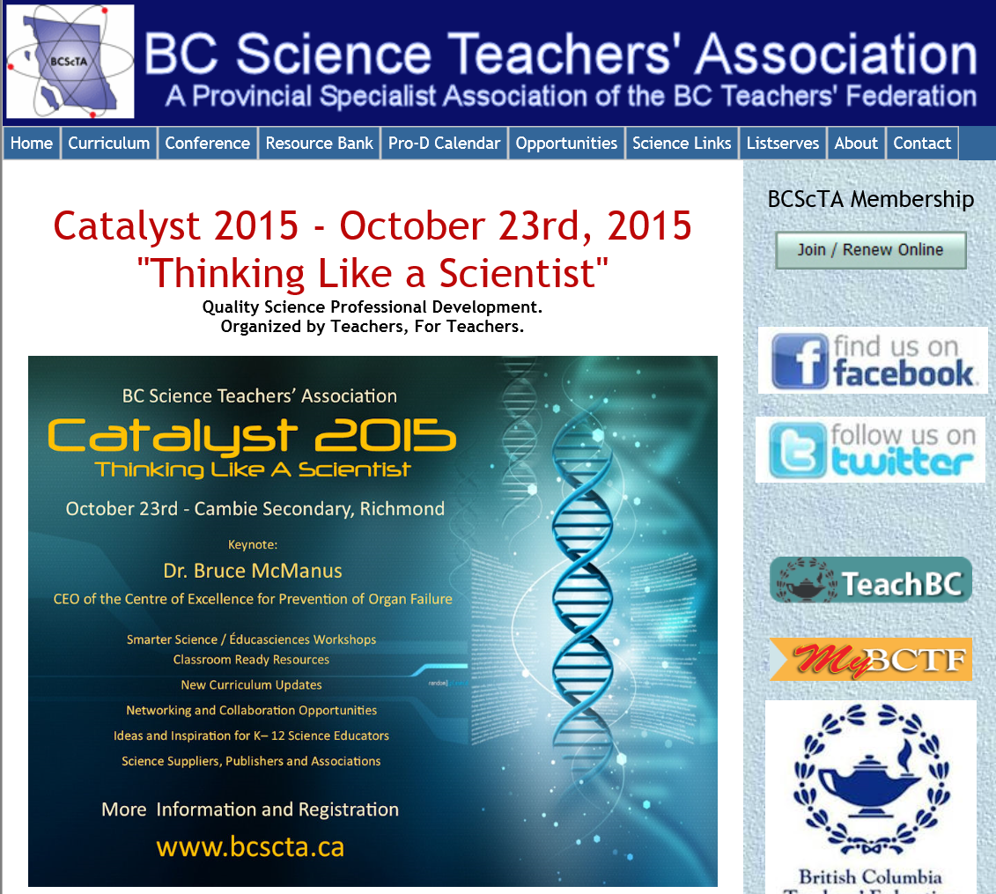

Workshops
»back to the previous page
2015 BCSCA Conference
Building Bridges
October 21-23, 2015
The conference will be located at the Pacific Gateway Hotel at Vancouver Airport, nicely located on the Fraser River in Richmond, a quick shuttle ride from the airport – ideal for people flying in to participate in our conference.
- Anxiety and its Discontents FULL
Middle
» more information
- Are you with me? The Power of our Relationship Bridge
» more information
- BC Children's Hospital Field Study Day: Child and Youth Mental Health
All
» more information
- Be Safe! Child Safety Program
Elementary
» more information
- Becoming trauma informed: A relational approach for school settings FULL
All
» more information
- Building Capacity: The Nurtured Heart Approach in School Settings
All
» more information
- Building Resilience (Trauma-Proofing) with Sensory Straatgies & Attachment
Elementary
» more information
- Bullying can be stoppped learn how
All
» more information
- Chartered Professional Accountants of BC
Secondary
» more information
- ChatterHigh - a Postsecondary & Career Exploration Activity
All
» more information
- Collaborative approach to building supports for youth
All
» more information
- Connecting with youth about their sexual health
All
» more information
- Coping with Cutting: A school's guide OFFERED MULTIPLE TIMES
All
» more information
- Developing Resilient, Active, and Flourishing Students
All
» more information
- DO LESS BUT ACCOMPLISH MORE WITH LIFE STRESS REDUCTION!
All
» more information
- Eating Disorders - what you can do to help?
All
» more information
- Generation Stressed- Empowering Children in the Face of Stress
Elementary
» more information
- Healthy Youth Relationships
Secondary
» more information
- High conflict divorce: Practical hints for counsellors CANCELLED
All
- Kids have stress - and so do Adults!
All
» more information
- Legal Issues for School Counsellors
All
» more information
- Motivational Interviewing Basics
All
» more information
- Neuro Emotional Literacy Program (NELP) 4 Teens
Middle
» more information
- Online Course Selection with myBlueprint.ca
Secondary
» more information
- Parent-teen Conflict Dissolution
All
» more information
- Preparing Students with Disabilities for Competitive Post-Secondary Studies
Secondary
» more information
- Refugee Youth: A holistic approach to dealing with trauma
All
» more information
- Rethinking Drug Ed and Promoting Mental Health in BC Schools â€“ School Counsellors as Change Agents FULL
All
» more information
- Schizophrenia -
Secondary
» more information
- Sexual Exploitation in Today's World
All
» more information
- Stop Wondering, Start Knowing: A Mental Health Video Resource for Schools OFFERED MULTIPLE TIMES
Secondary
» more information
- Strategies and Resources for Supporting and Engaging Youth Struggling with Anxiety
Secondary
» more information
- Stresslr – An Interactive Online Stress Management Resource for Kids
Elementary
» more information
- Suicide Prevention
All
» more information
- The Neuroscience and Neuropsychology of Emotion for Counselors
All
» more information
- Tribal Theory - a creative response for dealing with traumatized students
All
» more information
- Understanding and Supporting Children & Youth Living With Grief
All
» more information
- Understanding and Treating Selective Mutism: School-Based Strategies
Elementary
» more information
- Video Game Addiction? A school counsellor's guide
All
» more information
- When everybody knows your name: Building social capital among BC youth in care
Secondary
» more information
- Where Words Can't Reach. Using the sand tray in elementary school
All
» more information
» back to the previous page

http://bcscaconference.ca/index.php?PHPSESSID=72550fc84491d17181a96e9407015345

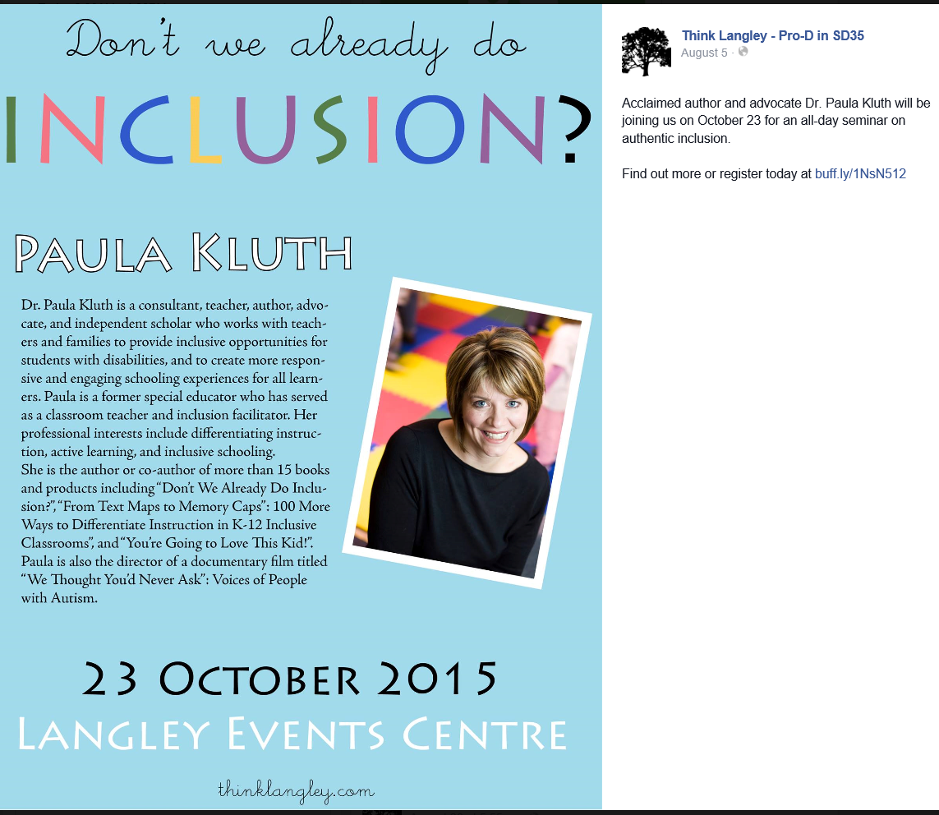
The Bio-Mechanics Behind Teaching and Learning Practical Vocal Exercises: The Legacy of Jo Estill (1921–2010)
Date: October 22, 2015, 9:20am–12:30pm
Location: SFU Burnaby, IRMACS Theatre, ASB 10900
Register: https://www.sfu.ca/tlc/programming/special/stlhe2015-encore-1.html

http://www.sfu.ca/education/gs/current-students/conf-events.html

Thriving in Youth with ASD – What Does it Take?
http://www.actcommunity.ca/education/act-events/thriving-in-youth-with-asd-what-does-it-take/
Friday, October 23rd, 2015
Jonathan Weiss, PhD
CIHR Chair in ASD Treatment and Care Research; Associate Professor, York University
Simon Fraser University - Downtown Campus
Vancouver, BC
Regular rate ends October 14th, 2015

or Register by form (pdf)
Level | Intermediate/Advanced
For | Family Members/Community Professionals
Focus | Youth and Young Adults with ASD including those with Intellectual Disabilities
Autism-specific? | Yes

About the Event
Jonathan Weiss has identified thriving as an important but almost unused term in the realm of autism research which is largely focused on problem behaviors and the negative impact of autism on the lives of young people. In his presentation Dr. Weiss will look at how to promote positive outcomes in youth with ASD, including those with Intellectual Disability, by focusing on indicators such as happiness, satisfaction and resilience. This presentation has significant implications for educators, families and therapists as they look at the pivotal interventions that will have the biggest impacts on youth with ASD as they prepare and enter into adult life, specifically, interventions that target social-communication difficulties and promote social interaction and community inclusion for youth with ASD.

About the Presenter
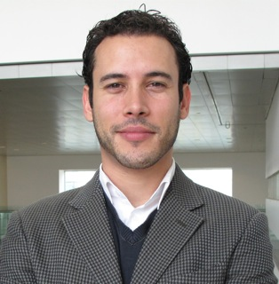Dr. Weiss holds the Canadian Institute of Health Research Chair in Autism Spectrum Disorders Treatment and Care Research. He is a Clinical Psychologist and Associate Professor in the Department of Psychology at York University in Toronto. Dr. Weiss' research focuses on the prevention and treatment of mental health problems in people with ASD and/or intellectual disabilities across the lifespan. He is interested in their health service needs, their emergency service use, and their experiences of psychiatric crisis. Families play a critical role in the health of people with developmental disabilities by providing them with care and enabling their access to health services, and he is currently focused on learning about the experience of family caregivers. He is interested in program development and evaluation, and in particular on the impact of Special Olympics on the psychological well-being of participants, and of cognitive-behavioural and social skill interventions to promote resilience and improve the mental health of children and adults with developmental disabilities.
See Dr. Weiss speak on Emergency Services, Hospitalizations and Mental Health Care for Adolescents and Adults with ASD from April, 2013.

Cost/Funding
 | Date | Parents, Para-Pros & Students | Professionals
Early Bird Rate ends | September 15th, 2015 | $100 | $150
Regular Rate ends | October 14th, 2015 | $150 | $200
Late Rate begins | October 15th, 2015 | $200 | $250

Bursaries
ACT fundraises to provide bursaries for low-income participants and/or those travelling from outside their home regions to an event. ACT only provides bursaries prior to registration. Please read Bursary Information. You are welcome to call or email ACT's office (info@actcommunity.ca) for more information. ACT provided $24,000 in bursaries in 2014 and gratefully accepts donations to our bursary fund to allow us to provide a greater level of support. Donate to our bursary fund.

Autism Funding
Parents who receive Autism Funding may use 20% of the total for equipment, books, training and travel costs. ACT's live events are considered eligible expenses by the Autism Funding Branch.
More Autism Funding Information >

Workshop Location
Simon Fraser University - Downtown Campus, Room 1900 - Fletcher Challenge Theatre
Harbour Centre, 515 West Hastings Street
Vancouver, BC
Click to view full map
Parking is expensive downtown, however this venue is very accessible by public transit. Contact Translink for directions and schedules for the West Coast Express, Skytrain, Seabus and bus routes.

Hotel Information
Looking for a hotel? View the hotels that give ACT a preferred rate.

Workshop Schedule
8:30 | - | 9:00 | Check-in
9:00 | - | 9:15 | Introductions
9:15 | - | 10:30 | Session 1 - Dr. Weiss
10:30 | - | 10:45 | Break (light snacks will be served)
10:45 | - | 12:00 | Session 2 - Dr. Weiss
12:00 | - | 1:00 | Lunch (buy or bring your own)
1:00 | - | 2:30 | Session 3 - Panel Discussion led by Professor Anthony Bailey, UBC

